PROGRAMING FUNDAMENTAL (theory)

A.HANNAN
SU92-BSSEM-177

TASK 1:

#include <iostream>
using namespace std;

double calculateAverage(int arr[], int n)
{
int sum = 0;

for(int i = 0; i < n; i++)
{
sum = sum + arr[i];
}

return (double)sum / n;
}

int main()
{
int n;
cin >> n;

int arr[100];

for(int i = 0; i < n; i++)
{
cin >> arr[i];
}

cout << calculateAverage(arr, n);

return 0;
}
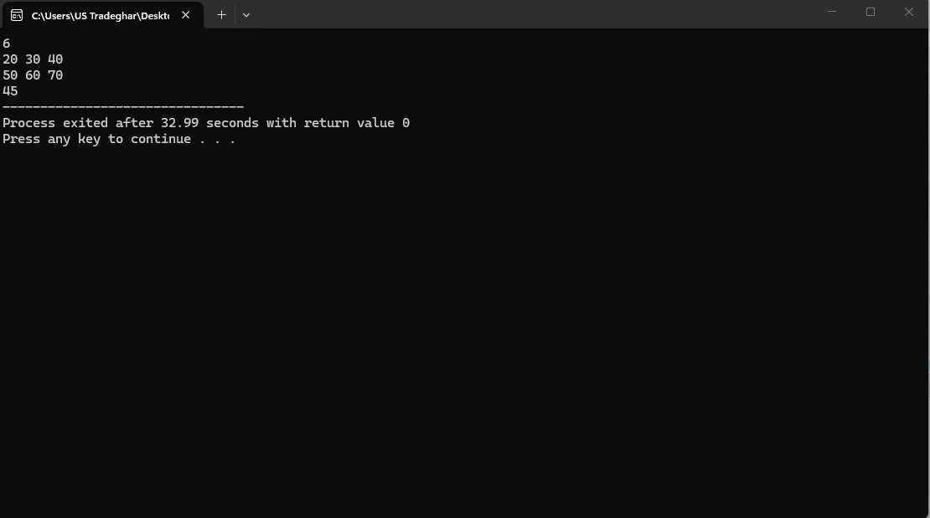

TASK 2:

#include <iostream>
using namespace std;

int calculateLowest(int arr[], int n)
{
int low = arr[0];

for(int i = 1; i < n; i++)
{
if(arr[i] < low)
{
low = arr[i];
}
}

return low;
}

int calculateHighest(int arr[], int n)
{
int high = arr[0];

for(int i = 1; i < n; i++)
{
if(arr[i] > high)
{
high = arr[i];
}
}

return high;
}

int main()
{
int n;
cin >> n;

int arr[100];

for(int i = 0; i < n; i++)
{
cin >> arr[i];
}

cout << "Lowest Score: " << calculateLowest(arr, n) << endl;
cout << "Highest Score: " << calculateHighest(arr, n);

return 0;
}
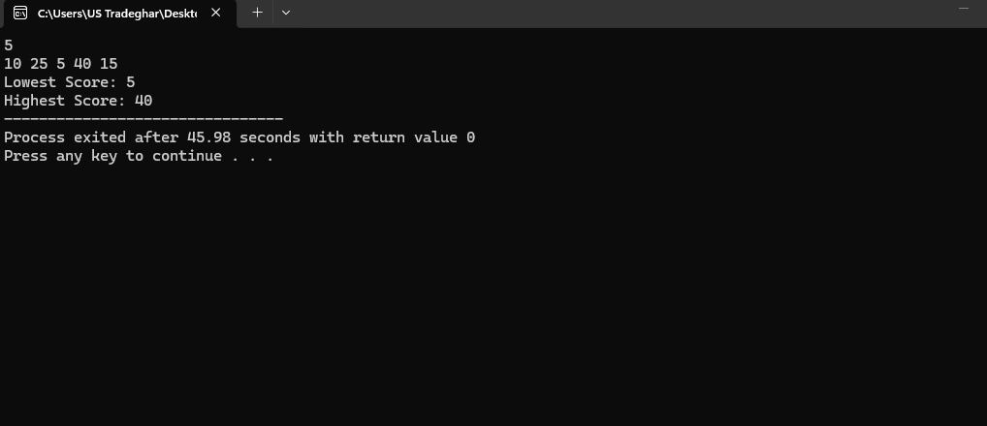

#include <iostream>
using namespace std;

int calculatePower(int base, int exponent)
{
int result = 1;

for(int i = 0; i < exponent; i++)
{
result = result * base;
}

return result;
}

int main()
{
int base, exponent;

cin >> base >> exponent;

cout << base << " raised to the power "
<< exponent << " is: "
<< calculatePower(base, exponent);

return 0;
}
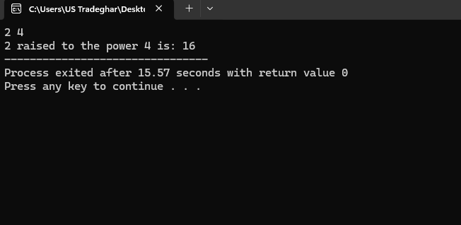

TASK 4:
#include <iostream>
using namespace std;

double calculateVoltage(double current, double resistance)
{
return current * resistance;
}

int main()
{
double current, resistance;

cin >> current >> resistance;

cout << "Total Voltage: "
<< calculateVoltage(current, resistance)
<< " V";

return 0;
}
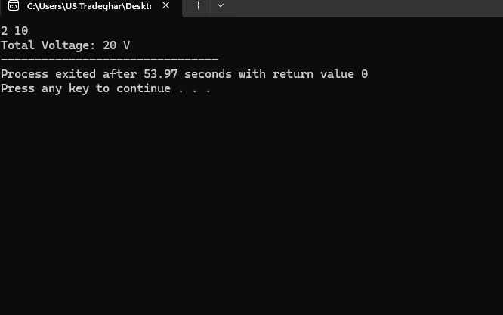
TASK 5:
#include <iostream>
using namespace std;

bool searchPlayer(char arr[], int size, char target)
{
for(int i = 0; i < size; i++)
{
if(arr[i] == target)
{
return true;
}
}

return false;
}

int main()
{
char team[5] = {'b','r','s','f','a'};

char target;
cin >> target;

if(searchPlayer(team, 5, target))
{
cout << "Player is in the team";
}
else
{
cout << "Player not found";
}

return 0;
}

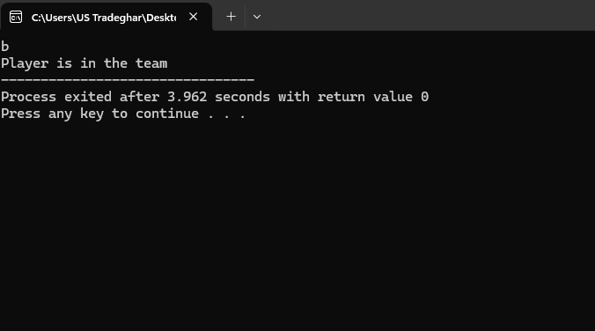

TASK 6 :
#include <iostream>
using namespace std;

int findLength(char word[])
{
int count = 0;

while(word[count] != '\0')
{
count++;
}

return count;
}

int main()
{
char word[100];

cin >> word;

cout << "Length of the word is: "
<< findLength(word);

return 0;
}

